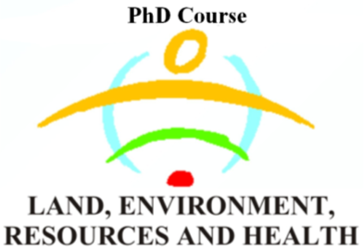 | UNIVERSITY OF PADOVA  DIPARTMENT LAND, ENVIRONMENT, AGRICULTURE AND FORESTRY (TESAF)  AGRIPOLIS – Viale dell’Università, 16 – 35020 LEGNARO (Padova)  Tel. +390498272685 - Fax 0498272686 – P.IVA 00742430283 | 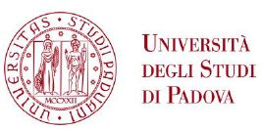

PhD Confidentiality Research Agreement

between
…..
(the ”Organization”)

and

name of the PhD student
Department of Land, Environment, Agriculture and Forestry
University of Padova
Via dell'Università, 16
35020 - Legnaro (PD), Italy
(the ”PhD Student”)

Background

This agreement lays out the general terms of responsibilities, data usage and confidentiality between the organization and the PhD student based on previous informal agreement to collaborate on the research topic of mutual interest. The PhD Student would like to perform field work and get access to certain data and information regarding the Organization’s and its individual members’ activities in order to conduct her/his research under overall topic of “…”. The PhD Student is expected to finalize her/his PhD project in date. The research is being conducted under general supervision of name of supervisor(s), a member of the PhD Programme.

Rights and responsibilities

The Organisation
Agrees to provide necessary support to the PhD student to perform research work and grant access to required data and information regarding the project during the whole research period. The Organization reserves the right to deny access confidential information of its own choice.

The PhD Student

Agrees to conduct a research with due diligence, treat the given information with due respect to agreed terms and conditions and update the Organization about the progress of her/his research. For the purpose of academic integrity, the PhD student reserves the right to analyse and publish data obtained outside of direct support and provision of the Organization. However, the PhD student shall consult the Organization for reliability of this kind of data.

- Main contacts

The PhD Student’s main contact at the Organization is currently: name of the contact person. The role of the main contact of the Organization is coordinate the collaboration work with the above-mentioned project, represent the Organization in any related interviews or information gathering activities, and review any documents produced by the PhD student on behalf of the Organization, prior to publishing.

- Confidentiality and visibility

The PhD Student’s obligations as described herein shall also be in effect after the termination of this Agreement. The PhD student
- agrees not to divulge, publish, or otherwise make known to unauthorized persons or to the public any information obtained in the course of this research project that was classified as confidential by the Organization;
- agrees to notify the Organization immediately should she become aware of an actual breach of confidentiality or a situation which could potentially result in a breach.

- Know-how, copyright and inventions

The PhD Student retains the rights to her/his publications in which she uses data and other information from the Company and/or its representatives, subject to the applicable laws and regulations. The PhD Student shall submit an electronic copy of her/his results and publications to the Organization before any kind of publication of the data obtained and agreed upon. The PhD Student shall ensure that data and other information is anonymized in case it is required by the Organization. The Organization shall have the right to remove certain business specific information of a confidential nature that it provided prior to any publication.
The Organization and/or its representatives shall be entitled to use the data and publications without limitations and without compensation to the PhD Student, provided that they are properly cited and are subject to the applicable laws and regulations.

- Commencement and termination

This Agreement shall commence on date. The preliminary timetable as follows:

Academic year | Location | Activities

This Agreement shall terminate automatically without notice once the PhD Student has passed the PhD project or on October, 2019 whichever is the sooner.

- Miscellaneous

The PhD Student will contact the relevant authorities in order to clarify which certificates that are necessary for the PhD Student’s field work in (i.e. visa, residence permit, work-permit, etc.) before travelling to other countries.
The PhD Student consents to the Organization holding and processing personal data, including personal sensitive data, regarding the PhD Student for the purposes of the administration and management of its business as well as compliance with laws and regulations.

Date: ___________ | Date: ___________ | Date: ___________
Contact person  Of the Organization | PhD student in LERH Programme, University of Padova | Supervisor(s) for the PhD Programme

